**Lab 1 -- Part 2 : Using Wireshark in Kali to look at ICMP packets**

due 9/18 @ 3:00 PM ….And be ready for a quiz on 9/18

1. Access the ProxMox Kali VM (those several students that are still having authentication problems, use your own laptop running Kali in VMWare.)
2. Bring up a terminal command prompt (the second icon on the left side of the screen)
3. Type in the next command, **but don’t hit enter** yet (If you do accidently hit enter, then you will not get the DNS packets in the sniff)

ping www.guimp.com

1. Don’t close the window …. But bring up Wireshark (Applications > 09 - Sniffing…> Wireshark) and start listening on the Ethernet interface
2. **Now** switch back to **terminal cmd prompt** and hit enter to ping the website
3. **Quickly** go back to Wireshark and **stop the sniff** and **save it** as

Lab1-*section#*-*yourname*-Linux_icmp.pcap

1. Now, explore the sniff capture and apply a filter to only show the packets with the ICMP protocol : ip.proto == ICMP
2. Screenshot the filtered packet results and place the picture in here :

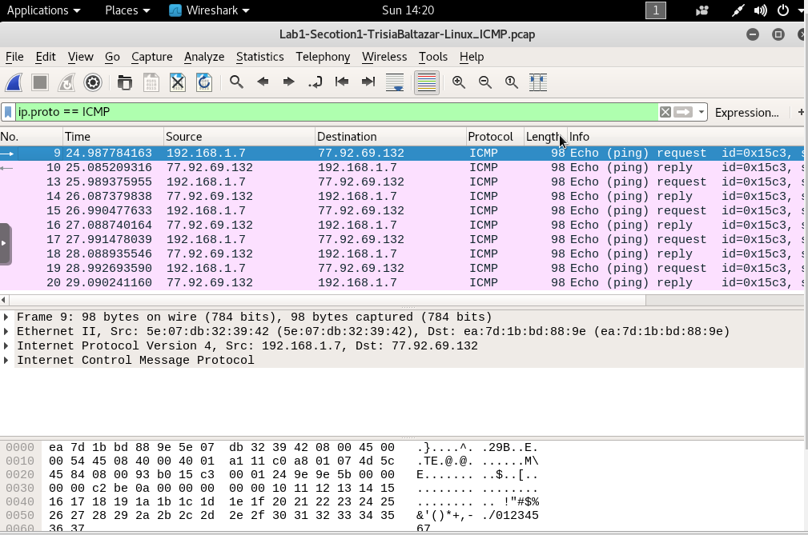

1. Now let’s explore the first ICMP packet in depth. Still in Wireshark, highlight one of the ICMP packets where you are the source IP. Look in the detail section (in the middle), and answer the following:

What is the Frame size in bytes ? _98 bytes_______

What is the **actual** source MAC? ___5e:07:db:32:39:42______________________

What does shark identify as the “vendor” portion of the source MAC? ______________

What is the **actual** destination MAC? ____ea:7d:1b:bd:88:9e_____________________

What does shark identify as the “vendor” portion of the destination MAC? ______________

Expand the Internet Control Message Protocol header.

What is the ICMP Type number ? ___8____ and associated meaning ? ___Echo (Ping) Request_____________

Expand the Internet Protocol header.

What is the value of **Time to live** ? _____64______

Describe the payload data :

The payload data had 48 bytes. It had random characters with lots of periods in the beginning and the number 1-7 at the end (ASCII). Here is a screenshot:

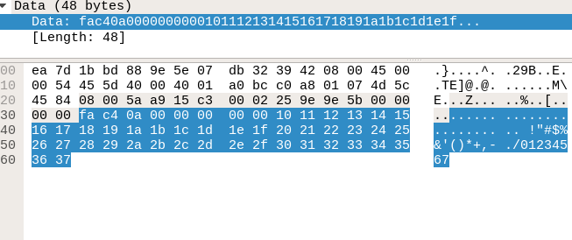

1. Now let’s explore the ICMP packet response in depth. Highlight the ICMP packet where you are the destination IP. Look in the detail section (in the middle), and answer the following:

Expand the Internet Control Message Protocol header.

What is the ICMP Type number ? ___0____ and associated meaning ? __Echo(Ping) Reply______________

Expand the Internet Protocol header.

What is the value of **Time to live** ? ____51_______

Did the payload data change? _no___________

1. Compare these results with Part 1 of the lab (Windows ping) – identify the components of the ping packets and their values that are different below:
2. Save this updated Word file with your responses as

Lab1-*section#*-*yourname*-Linux_icmp.docx

1. Attach the the pcap file from Step 6, and your updated docx file to the Assignment